Laboratorul 1

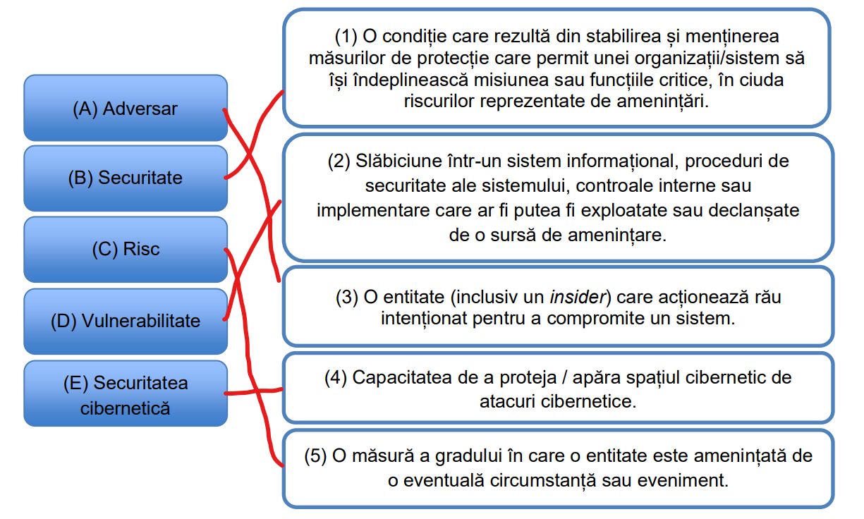
1.

2.
Am vizionat.
3.
19 + 10 = 29
29/2 = 14 rest 1
14/2 = 7 rest 0
7/2 = 3 rest 1
3/2 = 1 rest 1
1/2 = 0 rest 1
29 = 1*2⁰ + 0*2¹ + 1*2² + 1*2³ + 1*2⁴ => 29₁₀ = 11101₂
11101₂ = (1*2⁰ + 0*2¹ + 1*2² + 1*2³ + 1*2⁴)₁₀ = 29₁₀

1A2B₁₆
1₁₆ = 0001₂
A₁₆ = 1010₂
2₁₆ = 0010₂
B₁₆ = 1011₂
1A2B₁₆ = 0001101000101011₂
0001101000101011₂ = (0001₂ ++ 1010₂ ++ 0010₂ ++ 1011₂)₁₆ = 1A2B₁₆

4.
MATEI = 77 65 84 69 73
66 82 65 86 79 = BRAVO

5.
UNGUREANU = VU5HVVJFQU5V
U3VudCBzdHVkZW50IGxhIEZNSS4= = Sunt student la FMI.

6.
Malware = Hardware, firmware, or software that is intentionally included or inserted in a system for a harmful purpose.
Virus = A computer program that can copy itself and infect a computer without permission or knowledge of the user. A virus might corrupt or delete data on a computer, use e-mail programs to spread itself to other computers, or even erase everything on a hard disk.
Dropper = A dropper is a Trojan horse that has been designed to install malware onto a computer.
Downloader = A downloader is a type of malicious software designed to install additional harmful programs onto a victim’s device without their knowledge.
Trojan (horse) = A computer program that appears to have a useful function, but also has a hidden and potentially malicious function that evades security mechanisms, sometimes by exploiting legitimate authorizations of a system entity that invokes the program.
Spyware = Software that is secretly or surreptitiously installed into an information system to gather information on individuals or organizations without their knowledge.
Riskware = Riskware is software whose installation and execution poses a potential risk to a host computer.
Ransomware = Ransomware is a type of malware that encrypts the victim's personal data until a ransom is paid.
Adware = Adware is software that generates revenue by automatically displaying online advertisements in the user interface or on a screen presented during the installation process.
Worm = A self-replicating program that propagates itself through a network onto other computer systems without requiring a host program or any user intervention to replicate.
Obfuscate = The deliberate act of making code, data, or network traffic difficult for humans or machines to understand, reverse-engineer, or detect, while preserving its original functionality.

